Nginx: Web Server

**Pre- Requisites:**

* Nginx installed
* Mysql installed
* Php-fpm installed

**Resource:**

* [**https://www.digitalocean.com/community/tutorials/how-to-install-linux-nginx-mysql-php-lemp-stack-ubuntu-18-04**](https://www.digitalocean.com/community/tutorials/how-to-install-linux-nginx-mysql-php-lemp-stack-ubuntu-18-04)

**Q 1) Localhost and 127.0.0.1 shows different content.**

**Step 1:** Install nginx using command

$ sudo apt install nginx

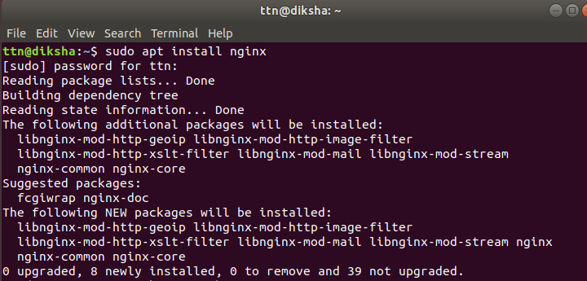

**Step 2:** Make a new directory in </var/www/html> named New_dir and in this create a new index.html page. Similarly make changes in the index.html in </var/www/html>.



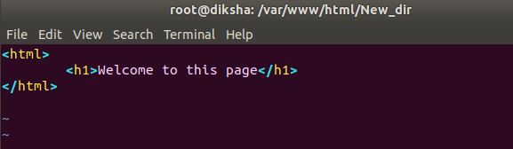

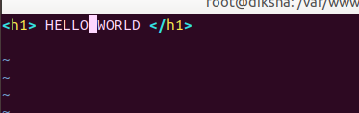

**Step 3:** Make a new configuration file in </etc/nginx/sites-available> named newconfig

And give server name as 127.0.0.1 and make changes in root as /var/www/html/New_dir

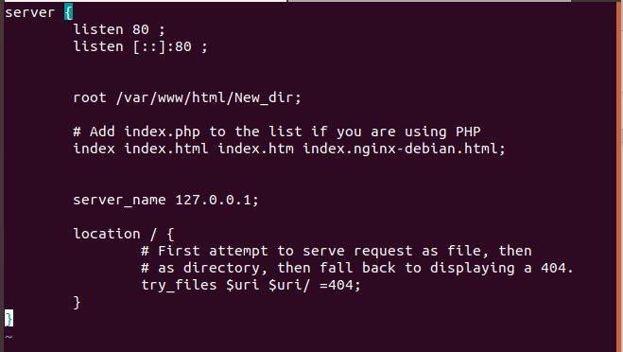

**Step 4:** Make a soft link of the above file in sites-enabled



**Step 5:** Test nginx using command:

$ nginx -t

And then reload it using command:

$ service nginx reload

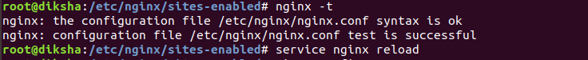

**Step 6:**  Now open localhost and 127.0.0.1 in the browser and you will find two different index pages

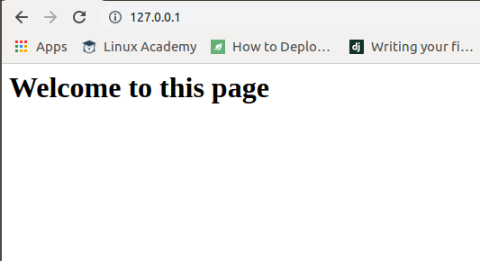

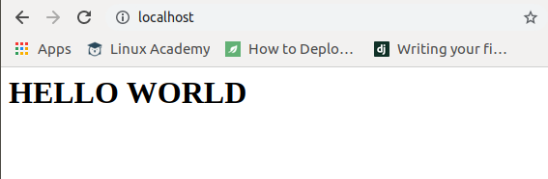

**Q 2) Apply authorisation on Nginx**

**Step 1:** Install apache utils by typing the underlying command.

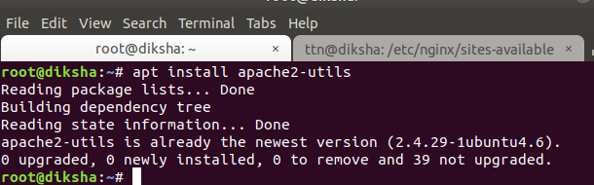

**Step 2:** Type the following command to generate password.

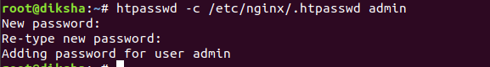

**Step 3:** Make changes in your configuration file i.e add the below line

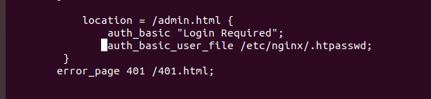

**Step 4:** Make admin.html and 401.html page in New_dir.

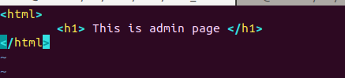

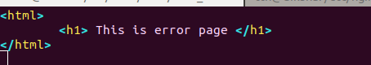

**Step 5:** Open the 127.0.0.1/admin.html

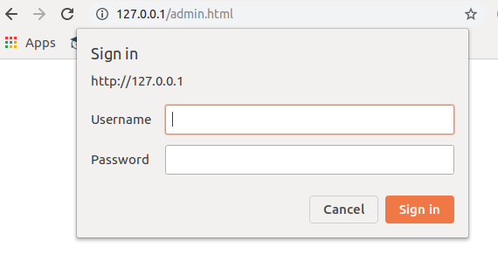

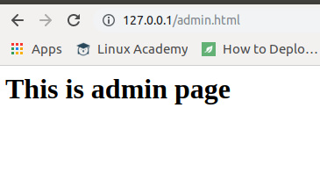

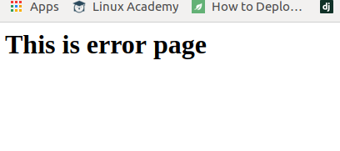

**Q 3) To generate a SSL Certificate.**

**Step 1:** Make a directory named ssl and then run openssl command to generate certificate.

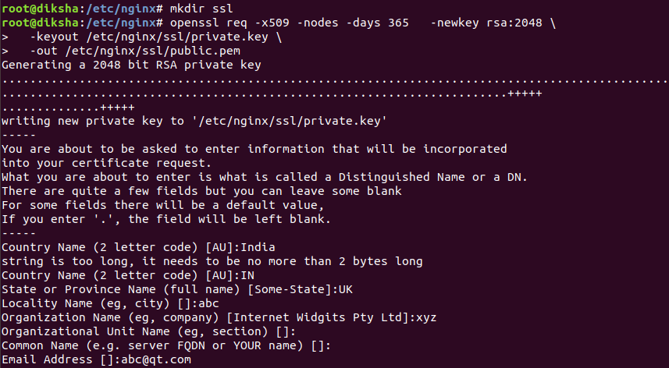

**Step 2:** Now test and reload nginx.

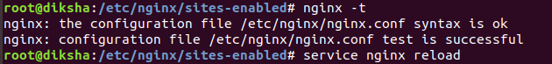

**Step 3:**  Now open browser and reload the page.

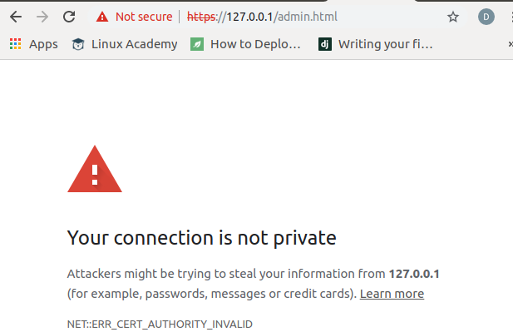

**Step 4:** Underlying is the self signed certificate.

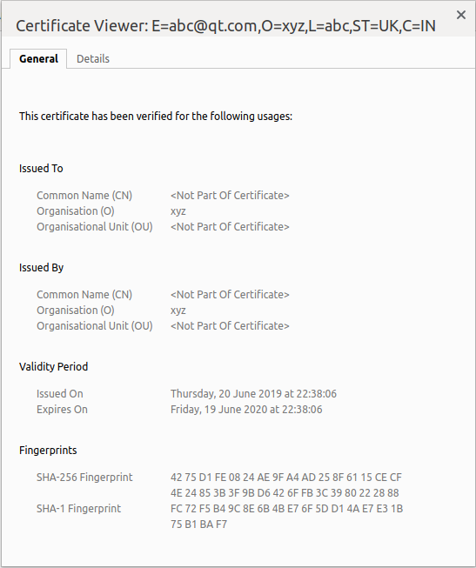

**Q 4) Change the access log format.**

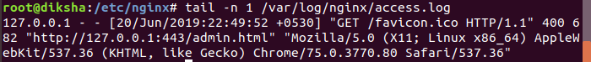

**Step 1:**Firstly, you need to define a valid log format for nginx:

log_format foo '$remote_addr - $remote_user [$time_local] '

'"$request" $status $bytes_sent ';

**Step 2:**Then, you need to link that format with your log file:

access_log /var/logs/nginx-test-access.log foo;

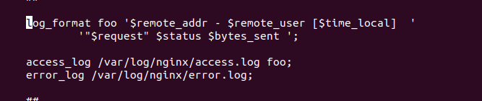



**Step 3:** Now check the log format again.



**Q 5) Host wordpress on nginx.**

**Step 1:** Install mysql and php.

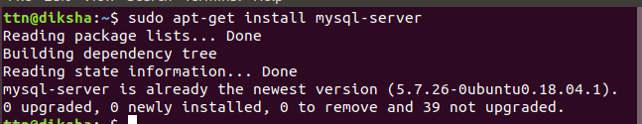

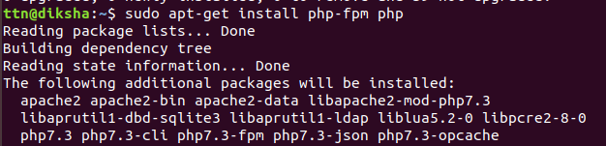

**Step 3:**First, we can create a separate database ”wordpress” that WordPress can control.

**Step 4:** Next, we are going to create a separate MySQL user account that we will use exclusively to operate on our new database.

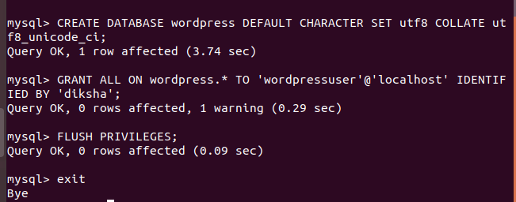

**Step 5:**download and install some of the most popular PHP extensions for use with WordPress by typing:

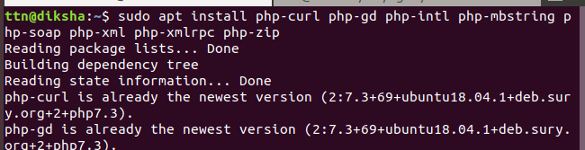

**Step 6:** Configure nginx

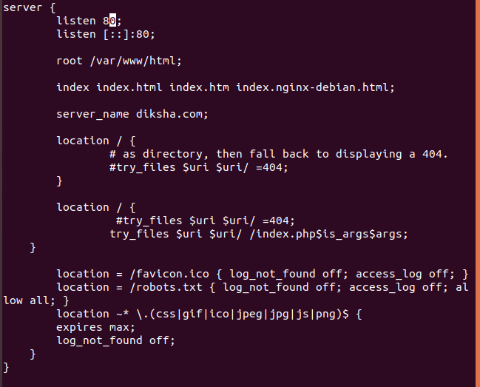

**Step 7:**Now that our server software is configured, we can download and set up WordPress.

**Step 8:**Change into a writable directory and then download the compressed release by typing:

$ cd /tmp

$ curl -LO <https://wordpress.org/latest.tar.gz>

**Step 9:**Extract the compressed file to create the WordPress directory structure:

$ tar xzvf latest.tar.gz

**Step 10:**We will be moving these files into our document root momentarily.Now, we can copy the entire contents of the directory into our document root.



**Step 11:**Now that our files are in place, we'll assign ownership them to the www-datauser and group. This is the user and group that Nginx runs as, and Nginx will need to be able to read and write WordPress files in order to serve the website and perform automatic updates.



## **Step 12:**Setting up the WordPress Configuration File.To grab secure values from the WordPress secret key generator, type:

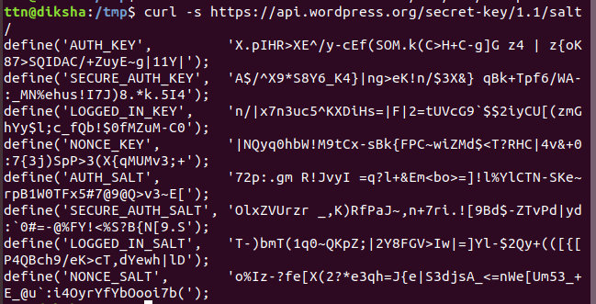

**Step 13:**Copy the output you received now.Now, open the WordPress configuration file.Delete those lines and paste in the values you copied from the command line:

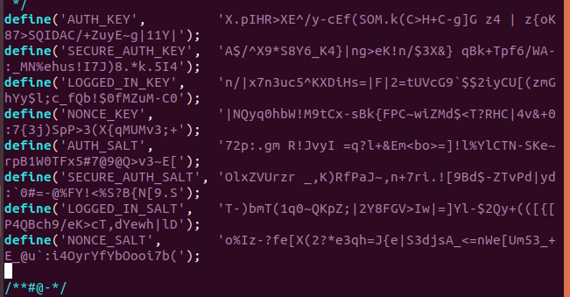

**Step 14:**Next, we need to modify some of the database connection settings at the beginning of the file.

**Step 15:** Open <diksha.com> in the browser.

